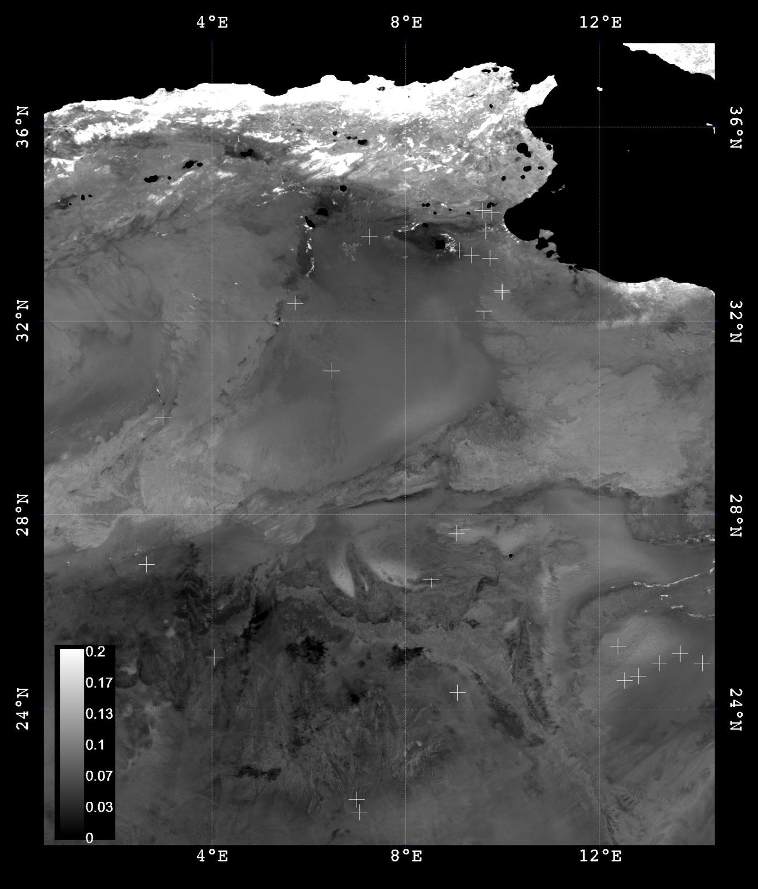

Figure 1. Location of the studied desert soil samples in the Sahara.

Background image is a SPOT-VGT NDVI composite (1st decade of July 2003)  
*grey level values are stretched between 0 and 0.2 (see scale)*

5spectres

Figure 2. Example of reflectance spectra obtained for the studied desert soils. Five samples show the variation range in the blue to NIR spectral domain

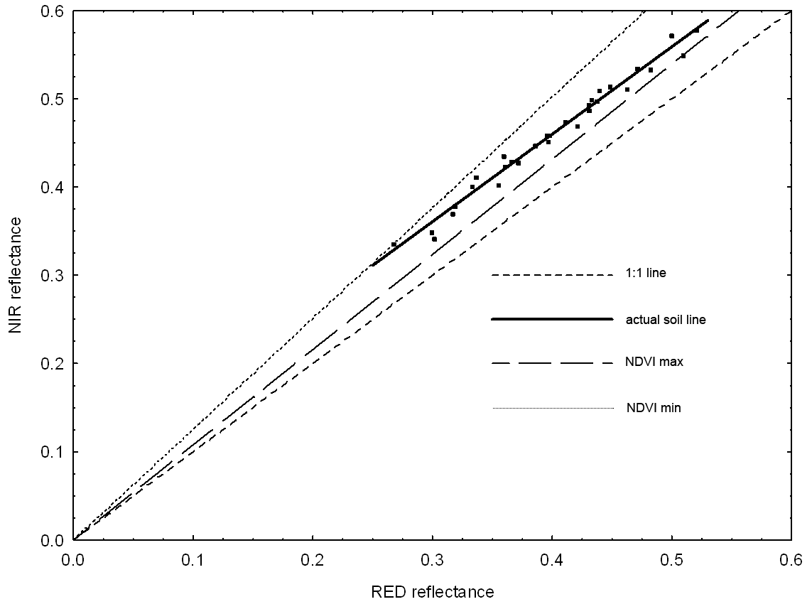

Figure 3. The 30 desert soil samples define a specific soil line in the Red/NIR plane. This line does not cross the origin, and points are dispersed around it, these are the two causes of soil noise in the NDVI, data from table 1.

plan_R_B_PIR

Figure 4. Desert soil samples in the Blue/Red/NIR space depict a ‘soil plane’. Viewed from the NIR/Red face (such as in fig 3) this 3D scattergramms explains the origin of the soil line thickness as the soil plane is not orthogonal to this face.

Regression_NDVI_IC2y= -0.0044 + 0.1581 x

r2= 0.861

Figure 5. Correlation between the NDVI (NIR/Red normalised difference) and Redness Index (Red/blue normalised difference) used to correct for soil noise (NDVI\* approach) .